various ML algorithms to build, validate, compare, select, and deploy statistical methods Step 1: Open dataset ‘ Big Class’ from sample data folder.

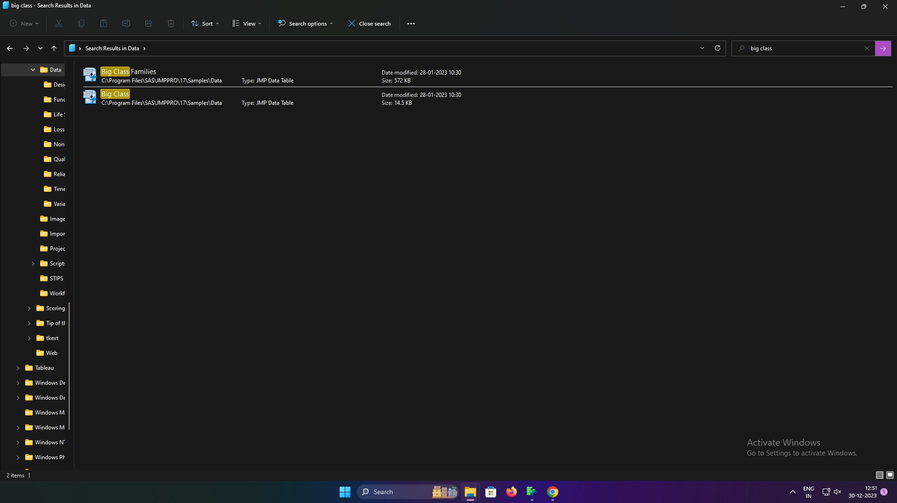

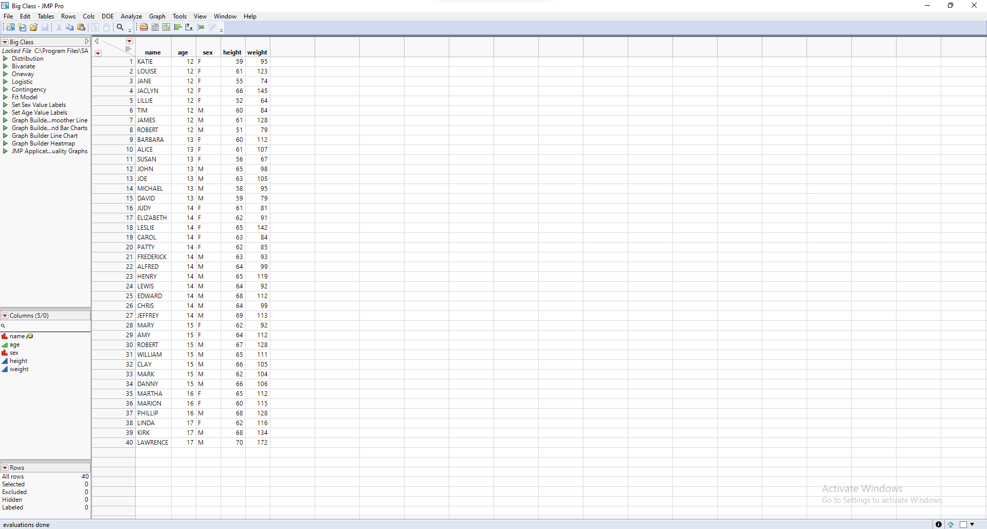

Select height in X axis and weight in X axis.

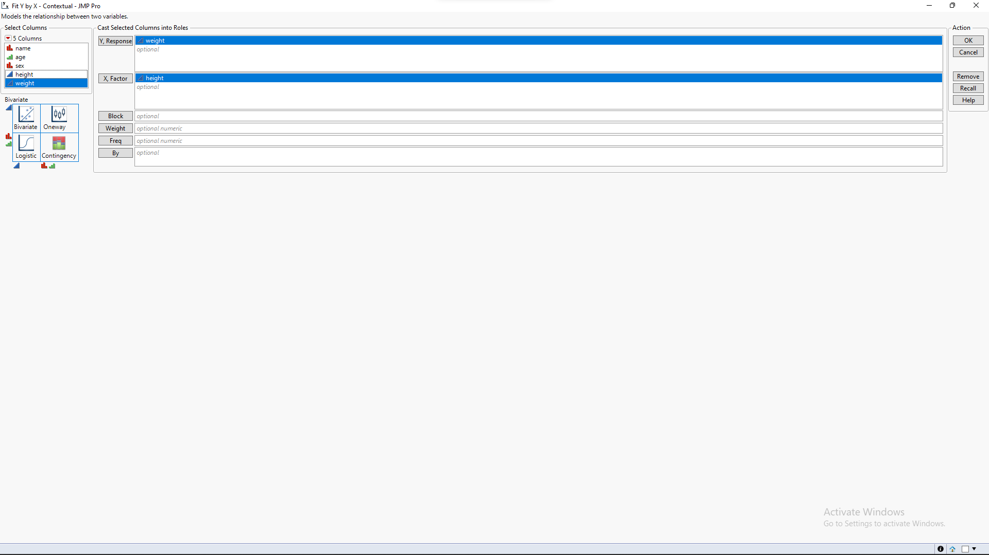

Step 3: In Order to plot the graph click on ‘OK’. Then click on fit line to add a straight line.

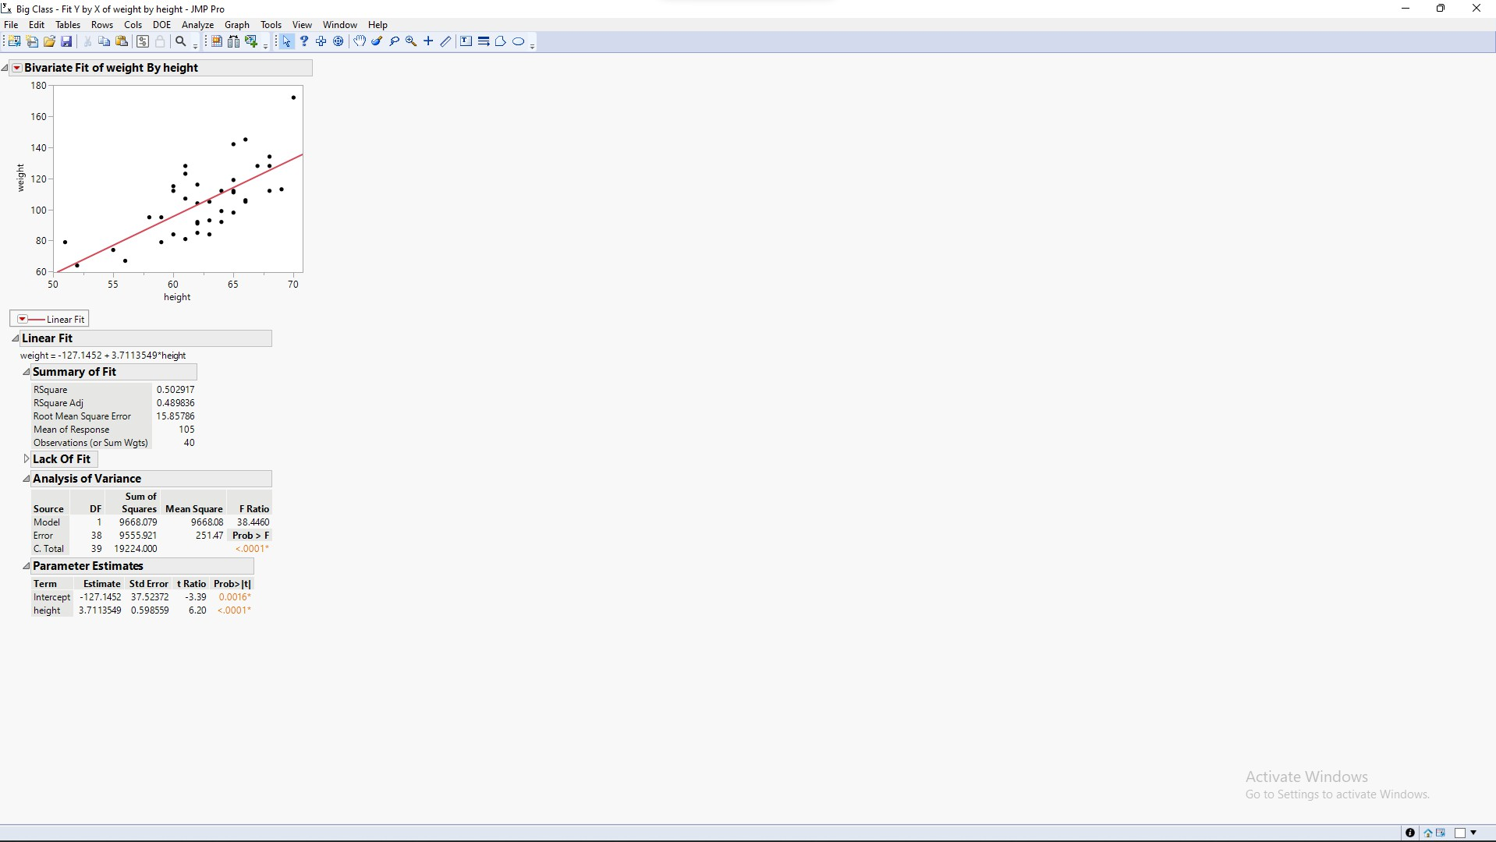

select the rest of the factors in the y axis

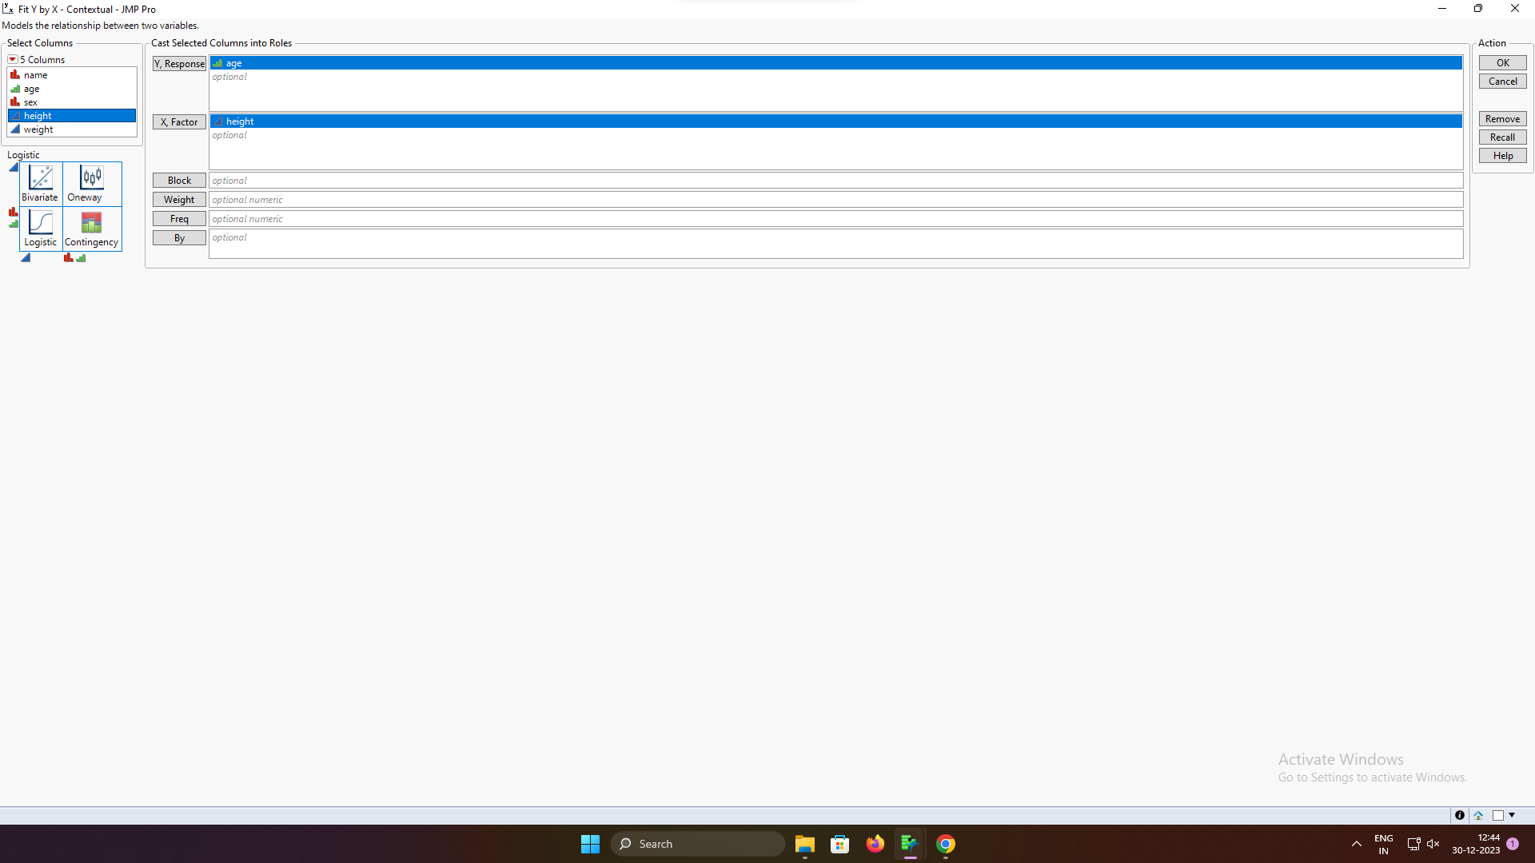

Step 5: This will provide a logistic graph

